LEAN and GREEN Practical Information
Introduction
The Lean and Green program was developed by Connekt, an independent network of companies and government officials whose members are committed to work together in order to improve the sustainable mobility in the Netherlands. The objective of this program is to provide support and expertise to companies wishing to attempt a radically different approach regarding the CO2 emissions generated by their transportation and logistics activities.
Lean and Green is based on a simple principle: the applying company (management and employees) drafts an Action Plan which identifies concrete and detailed measures (on a qualitative and quantitative level) enabling to decrease the CO2 emissions produced by its transportation and / or logistics activities by 20 per cent in 5 years.
The Cluster collaborates with Logistics in Wallonia, which launched the program in June 2013, and with the Ministry of Sustainable Development and Infrastructure. DART Consulting sprl will be responsible for the analysis, evaluation and certification of the Action Plans developed by the candidate.
- Steps for potential candidates
Candidate companies commit to a program that lasts for 5 to 7 months between the kick- off meeting and the delivery of the Lean and Green Award.

- Signature of the contract between Malik Zeniti and the applicant company
The contract “Ruleset and subscription document” has to be signed by the Cluster for Logistics and the applicant before the first workshop on December 16th 2015.

- Code of Practice and ruleset
The ruleset serves as the guideline for the Project and contains the general framework and code of practice.

- Evaluator
DART Consulting sprl will be responsible for the final evaluation of the Action Plans prepared by the candidates. Each plan will be evaluated and approved on the basis of pre-established criteria, which are identical for all the Plans.

- Confidentiality
The parties explicitly recognize that the exchanged information in the Lean and Green Programme is confidential and the content and related rights are the exclusive property of the party who discloses it.

- Timeframe
The first workshop will take place on December 16th at the Chamber of Commerce. The time of the second and third workshop will be determined at the first workshop.
The project will take 5 to 7 months and the awards ceremony will be held mid-2016.
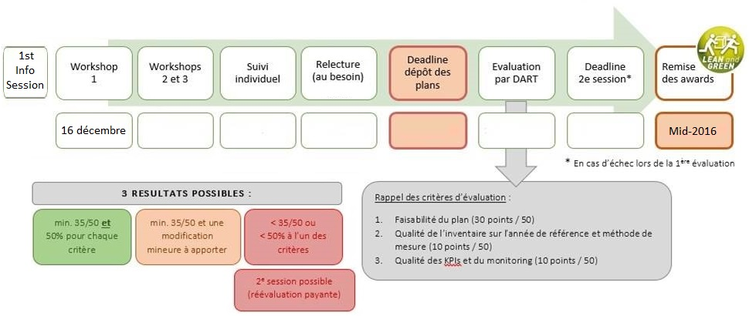
- After the reception of the Award
After official reception of the award, companies can communicate freely using the official logo Lean and Green all their supports. Recipients are encouraged to use it on their trucks, delivery documents, packaging, website ... etc.

- Costs
The price of participation in the Program Lean and Green is: € 3.000
A supplement of € 450 is required in case of a re-evaluation in order to cover additional information and costs.

- Contact
The Cluster for Logistics and Logistics in Wallonia can help you with further questions regarding the project.

Malik Zeniti
info@clusterforlogistics.lu
Tel: 42 39 39 849

Ronny Wolff
info@clusterforlogistics.lu
Tel: 42 39 39 848

Emilie Parthoens
epa@logisticsinwallonia.be
Tel: +32 (0)4 225 50 67

